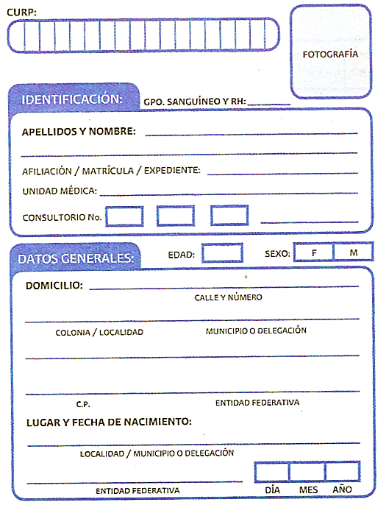

JUAREZ-ARGUELLES

ARNULFO 1F88 FACULT

0314370257,-,3

VERACRUZ 20 06 1937

1951

NICOLAS BRVO NO. 18

15 XX

VERACRUZ

92061 VERACRUZ VERACRUZ

LA BRISA TEMPOAL

2 FACULTATIVO

H.R. NO. 21

JUAA370620HVZRRR00